Backpropagation Intuition
Note: [4:39, the last term for the calculation for z31 (three-color handwritten formula) should be a22 instead of a21. 6:08 - the equation for cost(i) is incorrect. The first term is missing parentheses for the log() function, and the second term should be (1−y(i))log(1−hθ(x(i))). 8:50 - δ(4)=y−a(4) is incorrect and should be δ(4)=a(4)−y.]
Recall that the cost function for a neural network is:
J(Θ)=−1m∑t=1m∑k=1K[y(t)k log(hΘ(x(t)))k+(1−y(t)k) log(1−hΘ(x(t))k)]+λ2m∑l=1L−1∑i=1sl∑j=1sl+1(Θ(l)j,i)2
If we consider simple non-multiclass classification (k = 1) and disregard regularization, the cost is computed with:
cost(t)=y(t) log(hΘ(x(t)))+(1−y(t)) log(1−hΘ(x(t)))
Intuitively, δ(l)j is the "error" for a(l)j (unit j in layer l). More formally, the delta values are actually the derivative of the cost function:
δ(l)j=∂∂z(l)jcost(t)
Recall that our derivative is the slope of a line tangent to the cost function, so the steeper the slope the more incorrect we are. Let us consider the following neural network below and see how we could calculate some δ(l)j:
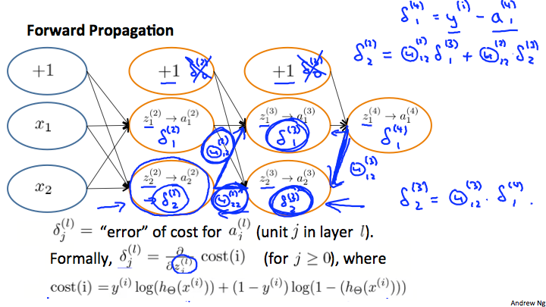
In the image above, to calculate δ(2)2, we multiply the weights Θ(2)12 and Θ(2)22 by their respective δ values found to the right of each edge. So we get δ(2)2= Θ(2)12*δ(3)1+Θ(2)22*δ(3)2. To calculate every single possible δ(l)j, we could start from the right of our diagram. We can think of our edges as our Θij. Going from right to left, to calculate the value of δ(l)j, you can just take the over all sum of each weight times the δ it is coming from. Hence, another example would be δ(3)2=Θ(3)12*δ(4)1.

